

**Department of Computer Science and Technology**

**106408 – Artificial Intelligence and Expert Systems**

**Project Proposal on**

# AI in Tourism

**Semester:**​ 5​th

**Program:**​ MCS

## NAME

**Javeria Imtiaz 10933**

**Rizwan 10754**

**Submitted to:**​ Sir SirajMunir

### PROPOSAL

**Problem**

Often people get confused while planning for a tour. First of all they hardly know places where they can spend a good time. Further there comes money constraint.

**How AI work in the field of Tourism**

The capacity for artificial intelligence to perform tasks that have traditionally required human cognitive function has made it especially useful for those in the travel industry, because deploying AI can save businesses time and money, while potentially eliminating human error and allowing tasks to be performed quickly, at any time of the day.

Finally, it is important to understand that the applications of AI within the [travel and tourism](https://www.revfine.com/travel-and-tourism/) industry are not limited to customer service alone. In actual fact, one of its most popular and effective uses is for gathering and interpreting data in order to draw conclusions about customers, business practices and pricing strategies.

**Artificial intelligence**

Algorithm: Decision Tree Algorithm

**Software Requirements:**

Windows Xp, Windows 7(ultimate, enterprise)

Visual studio 2019

**Result:**

This system solves problems of the client just by asking some questions. And it provides the answer that fit into users. It saves their money and time in finding and consulting a travel agency where they charge more.

**Project Link**

<https://github.com/ArtificialIntelligenceProject/AI-in-Tourism>

**Artificial intelligence**

**Decision Tree**

8 decision questions used in which decision tree algorithm work and give result.

Now, let’s create our tree! We will start with one simple question…

1. Are you Israel National? Y/N
2. Do you have a criminal record? Y/N.
3. How much are you willing to spend?
4. How many days you can holiday for?
5. Do you want to visit the northern areas? Y/N
6. Do you have any of the conditions; heart or lung issues, diabetes? Y/N
7. Do you want to visit the southern deserts? Y/N
8. Do you have any of the conditions; high or low blood pressure, kidney problems? Y/N

Yes

Are you Israel National?

No

Have a criminal Record

No

yes

How much are you willing to spend?

If expense < 150000

If expense > 150000

How many days you can holiday for

If no > 9

If no < 9

Do you want to visit the northern areas

yes

No

Do you want to visit the southern deserts?

Do you have any of the conditions; heart or lung issues, diabetes?

No

Yes

No

Yes

Do you want to visit the southern deserts?

Do you have any of the conditions; high or low blood pressure, kidney problems?

Yes

No

Yes

No

Do you have any of the conditions; high or low blood pressure, kidney problems?

Yes

No

**Result Bases on values**

Result

Predictors

|  |  |  |  |  |  |  |  |  |  |
| --- | --- | --- | --- | --- | --- | --- | --- | --- | --- |
| Conditions | Nationality | Criminal Record | Expense>150000 | Days>9 | Northern  areas | Medical Issues 1 | Southern desert | Medical Issues 2 |  |
| 1 | No | No | yes | yes | yes | No | Yes | No | Yes |
| 2 | Yes | No | Yes | Yes | Yes | No | Yes | No | No |
| 3 | No | Yes | Yes | Yes | Yes | No | Yes | No | No |
| 4 | No | No | No | Yes | Yes | No | Yes | No | No |
| 5 | No | No | Yes | No | Yes | No | Yes | No | No |
| 6 | No | No | Yes | Yes | No | No | Yes | No | Yes |
| 7 | No | No | Yes | Yes | Yes | NO | No | No | Yes |
| 8 | No | No | Yes | Yes | Yes | Yes | No | No | No |
| 9 | No | No | Yes | Yes | Yes | NO | No | Yes | No |

**Project Output:**

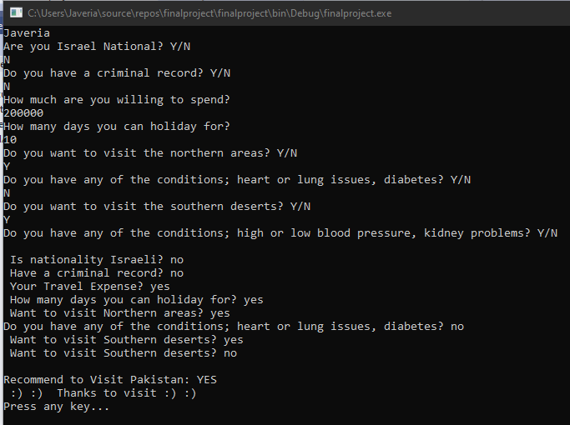

**Coding**

Class Customer used to declare the variables with get set method.

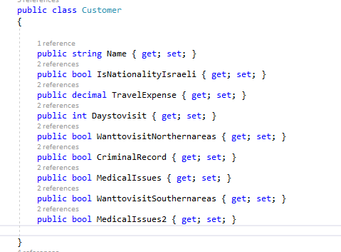

Here, Decision is a base class that contains Evaluate method and the source contains one additional derived type that contains a final decision of the tree (yes/no).

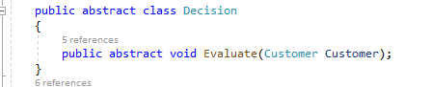

 A decision is essentially represented as a class that has references to true branch and false branch and contains a function that does the test:

Our Decision class will have to evaluate a Client. This evaluation will be based on a Decision Query (the question) and a Decision Result (the response).

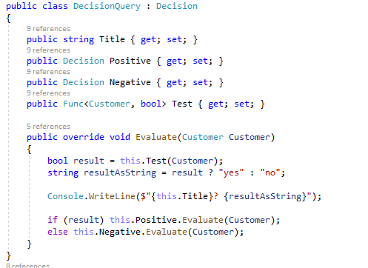

 our Main method. It is used to ask questions .

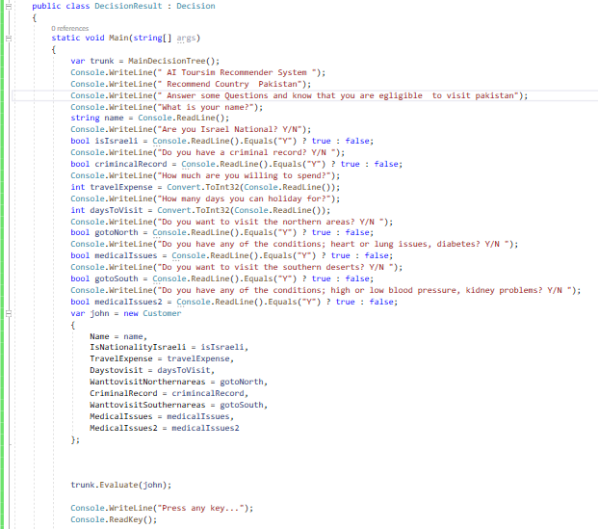

Use Method overriding for Result

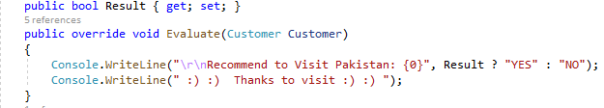

8 questions used in which decision tree algorithm work

Now, let’s create our tree!

By this text, you will understand the real value of a decision tree.

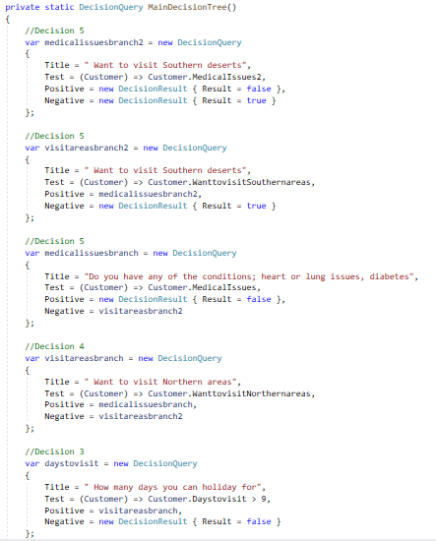

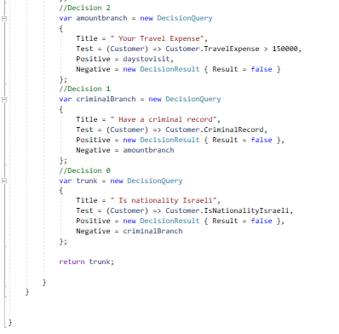

Code

using System;

namespace ConsoleApp4

{

public class Customer

{

public string Name { get; set; }

public bool IsNationalityIsraeli { get; set; }

public decimal TravelExpense { get; set; }

public int Daystovisit { get; set; }

public bool WanttovisitNorthernareas { get; set; }

public bool CriminalRecord { get; set; }

public bool MedicalIssues { get; set; }

public bool WanttovisitSouthernareas { get; set; }

public bool MedicalIssues2 { get; set; }

}

public abstract class Decision

{

public abstract void Evaluate(Customer Customer);

}

public class DecisionQuery : Decision

{

public string Title { get; set; }

public Decision Positive { get; set; }

public Decision Negative { get; set; }

public Func<Customer, bool> Test { get; set; }

public override void Evaluate(Customer Customer)

{

bool result = this.Test(Customer);

string resultAsString = result ? "yes" : "no";

Console.WriteLine($"{this.Title}? {resultAsString}");

if (result) this.Positive.Evaluate(Customer);

else this.Negative.Evaluate(Customer);

}

}

public class DecisionResult : Decision

{

static void Main(string[] args)

{

var trunk = MainDecisionTree();

Console.WriteLine(" AI Toursim Recommender System ");

Console.WriteLine(" Recommend Country Pakistan");

Console.WriteLine(" Answer some Questions and know that you are egligible to visit pakistan");

Console.WriteLine("What is your name?");

string name = Console.ReadLine();

Console.WriteLine("Are you Israel National? Y/N");

bool isIsraeli = Console.ReadLine().Equals("Y") ? true : false;

Console.WriteLine("Do you have a criminal record? Y/N ");

bool crimincalRecord = Console.ReadLine().Equals("Y") ? true : false;

Console.WriteLine("How much are you willing to spend?");

int travelExpense = Convert.ToInt32(Console.ReadLine());

Console.WriteLine("How many days you can holiday for?");

int daysToVisit = Convert.ToInt32(Console.ReadLine());

Console.WriteLine("Do you want to visit the northern areas? Y/N ");

bool gotoNorth = Console.ReadLine().Equals("Y") ? true : false;

Console.WriteLine("Do you have any of the conditions; heart or lung issues, diabetes? Y/N ");

bool medicalIssues = Console.ReadLine().Equals("Y") ? true : false;

Console.WriteLine("Do you want to visit the southern deserts? Y/N ");

bool gotoSouth = Console.ReadLine().Equals("Y") ? true : false;

Console.WriteLine("Do you have any of the conditions; high or low blood pressure, kidney problems? Y/N ");

bool medicalIssues2 = Console.ReadLine().Equals("Y") ? true : false;

var john = new Customer

{

Name = name,

IsNationalityIsraeli = isIsraeli,

TravelExpense = travelExpense,

Daystovisit = daysToVisit,

WanttovisitNorthernareas = gotoNorth,

CriminalRecord = crimincalRecord,

WanttovisitSouthernareas = gotoSouth,

MedicalIssues = medicalIssues,

MedicalIssues2 = medicalIssues2

};

trunk.Evaluate(john);

Console.WriteLine("Press any key...");

Console.ReadKey();

}

public bool Result { get; set; }

public override void Evaluate(Customer Customer)

{

Console.WriteLine("\r\nRecommend to Visit Pakistan: {0}", Result ? "YES" : "NO");

Console.WriteLine(" :) :) Thanks to visit :) :) ");

}

private static DecisionQuery MainDecisionTree()

{

//Decision 5

var medicalissuesbranch2 = new DecisionQuery

{

Title = " Want to visit Southern deserts",

Test = (Customer) => Customer.MedicalIssues2,

Positive = new DecisionResult { Result = false },

Negative = new DecisionResult { Result = true }

};

//Decision 5

var visitareasbranch2 = new DecisionQuery

{

Title = " Want to visit Southern deserts",

Test = (Customer) => Customer.WanttovisitSouthernareas,

Positive = medicalissuesbranch2,

Negative = new DecisionResult { Result = true }

};

//Decision 5

var medicalissuesbranch = new DecisionQuery

{

Title = "Do you have any of the conditions; heart or lung issues, diabetes",

Test = (Customer) => Customer.MedicalIssues,

Positive = new DecisionResult { Result = false },

Negative = visitareasbranch2

};

//Decision 4

var visitareasbranch = new DecisionQuery

{

Title = " Want to visit Northern areas",

Test = (Customer) => Customer.WanttovisitNorthernareas,

Positive = medicalissuesbranch,

Negative = visitareasbranch2

};

//Decision 3

var daystovisit = new DecisionQuery

{

Title = " How many days you can holiday for",

Test = (Customer) => Customer.Daystovisit > 9,

Positive = visitareasbranch,

Negative = new DecisionResult { Result = false }

};

//Decision 2

var amountbranch = new DecisionQuery

{

Title = " Your Travel Expense",

Test = (Customer) => Customer.TravelExpense > 150000,

Positive = daystovisit,

Negative = new DecisionResult { Result = false }

};

//Decision 1

var criminalBranch = new DecisionQuery

{

Title = " Have a criminal record",

Test = (Customer) => Customer.CriminalRecord,

Positive = new DecisionResult { Result = false },

Negative = amountbranch

};

//Decision 0

var trunk = new DecisionQuery

{

Title = " Is nationality Israeli",

Test = (Customer) => Customer.IsNationalityIsraeli,

Positive = new DecisionResult { Result = false },

Negative = criminalBranch

};

return trunk;

}

}

}}